IL training for OGA evidence submission

- Bring client up in pace using pace ID
- Click on application type
- 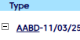
- Look for tracking number under application information:
  - If tracking number has T before it disregard and move onto the next client
  - If tracking number has a long tracking with no T, those are the ones we want to work
  - 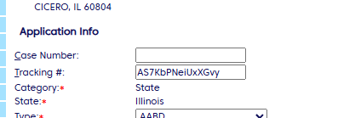
  - Copy the tracking number to add to evidence when saving
- Click classic scorecard to view evidence scanned into pace
  - Choose expand all
  - Click the boxes on all personal evidence that shows scanned
  - 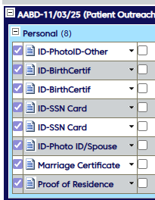
  - Top right choose documents and hit print
  - 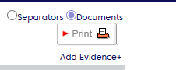
  - On the bottom of the screen a pop up will appear stating your document package is ready
  - 
  - Click on the statement and documents will open to be able to save
  - Choose to download or choose the printer to save as PDF
  - 
  - Save document as the name of the client and type of documents ex: Jones, E Verifications
  - Next open up CHC forms and look for a document called 2998 this will include 3 pages
    - Right click and choose to print and update pages on the print screen to only print the 2998 forms. Confirm that is all you see on the print screen and choose save * DO NOT SAVE ALL PAGES ONLY THE PAGES THAT SHOW 2998 AT THE BOTTOM
    - 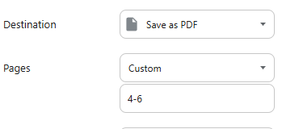
    - Save document with name of client and 2998. Ex Jones, E 2998
  - Next review financial under the scorecard and save any documents under that as client name and financial. Ex Jones, E financial documents
    - 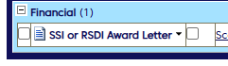
  - Next look for any medical records
    - Save documents as name of client and medical records. Ex Jones, E medical records
  - Next look for a form called 3801
    - Save document as name of client and 3801. Ex Jones, E 3801
  - Next look for application confirmation or tracking proof that will show the long tracking number and Choose page 1 and save document. only Ex Jones, E tracking proof
- Once all verifications are saved
  - Open contacts to see what agency is listed
  - If note states to fax use efax to fax all the documents saved for that client to the agency
  - If an email is listed with no note regarding fax only…
    - In outlook, open new email copy email and paste in the to box of the email
    - In the subject line, list the application tracking number and last name of client
    - Insert all saved documents for that client
    - In the body of the email
    - Please find all verifications for tracking number (list tracking number) Please associate with pending application for processing.
    - Choose Secure delivery
    - Send
  - Once email is sent and all documents attached
  - Note in pace: Sent email to (list agency and email) included the 2998, proof of tracking, all personal and financial verifications, 3801 and medical records scanned in pace for tracking number (list tracking number and name of client).
  - 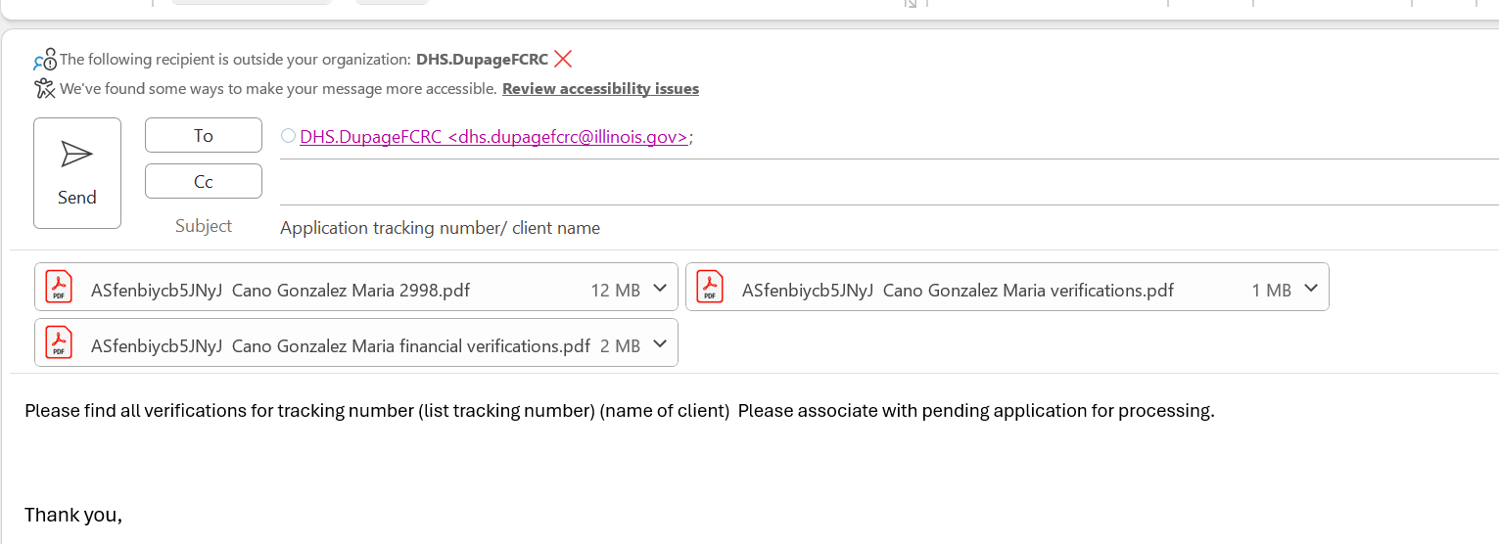
  - Note in pace if faxed: Sent fax to (list agency and fax number) included the 2998, proof of tracking, all personal and financial verifications, 3801 and medical records scanned in pace for tracking number (list tracking number and name of client).
- 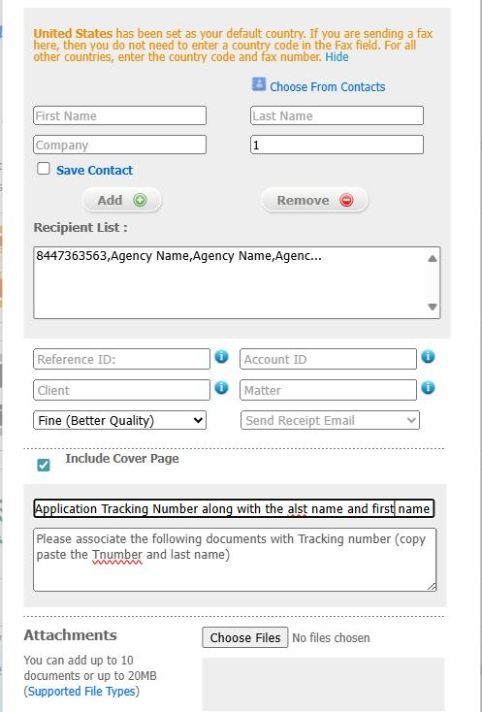

Contact me with any questions

